D[x.y] [title]

Table of Contents
1. Table of Contents 2
2. List of Figures 3
3. List of Tables 4
4. Executive Summary 8
5. INTRODUCTION 9
5.1. OBJECTIVE 9
5.2. LOCATION 9
5.3. OWNERSHIP 9
5.4. AUTHOR 9
5.5. REGULATION 9
5.6. BACKGROUND 10
6. DESCRIPTION OF BUILDING AND FACILITIES 11
6.1. BUILDING 11
6.2. FACILITES 12
6.3. BUILDING SELECTION JUSTIFICACION 14
7. TECHNOLOGIES TO BE IMPLEMENTED 15
7.1. TCM 15
7.2. PCM 16
8. WORKS TO PERFORM 17
8.1. ARCHITECTURE AND CIVIL WORKS 17
8.2. MECHANICAL INSTALLATIONS 18
8.3. ELECTRICAL INSTALLATIONS 20
8.4. REGULATION AND MONITORING 20
8.5. FIRE SAFETY 20
8.6. SANITATION 20
9. IMPLEMENTATION PROCEDURE 21
10. REPLICATION POTENTIAL 22
11. VALIDATION CRITERIA AND KPI SELECTION 23
12. DRAWINGS 24

List of Figures
Figure 1 xxxxxxxxxx 6

List of Tables

Table 1 xxxxxxxx 7

PROJECT DURATION: 1 January 2023 – xxxxxxxxx
GRANT AGREEMENT ID: 1010967 (Innovation Action)
WP: [x] DELIVERABLE: [x.y]
LEAD BENEFICIARY: [partner’s short name]
SUBMISSION DATE: [dd Month yyyy]
DISSEMINATION LEVEL: [Public / Confidential]
DUE DATE: [Mxy]
EPC RECAST Website: xxxxxxxxxx
REVISION HISTORY:

DATE | VERSION | AUTHOR/CONTRIBUTOR | REVISION BY | COMMENTS

DISCLAIMER
The opinion stated in this report reflects the opinion of the authors and not the opinion of the European Commission. All intellectual property rights are owned by HYSTORE consortium members and are protected by the applicable laws. Reproduction is not authorised without prior written agreement. The commercial use of any information contained in this document may require a license from the owner of that information.
ACKNOWLEDGEMENT
This project has received funding from the European Union’s Horizon 2020 research and innovation programme under grant agreement Nº 1010967.



Figure 1 xxxxxxxxxx

table 1 xxxxxxxx

EXECUTIVE SUMMARY
Lorem ipsum dolor sit amet, consectetur adipiscing elit. Donec rutrum vehicula tortor, non molestie velit laoreet luctus. Cras bibendum suscipit leo, quis volutpat leo aliquam ac. Ut

INTRODUCTION

OBJECTIVE
Purpose of the commissioning document is to establish a procedure for the technical commissioning of the systems to be implemented.
The main target group are the demo site owners, as well as the commissioning engineer for the different sites.

LOCATION
- Name: Abadia de Montserrat
- Adress: Santuari de Montserrat, s/n
- Town: Monistrol de Montserrat 08199 (Barcelona)

OWNERSHIP
- Name: L’Agrícola Regional, SA (L’ARSA)
- ID: A-28059483
- Adress: Santuari de Montserrat, s/n
- Town: Monistrol de Montserrat 08199 (Barcelona)

AUTHOR
- Name: Manuel Marin Giménez
- Company: ARCbcn
- Adress: c. Pau Claris 97, 1r-2a, 08009, Barcelona

BACKGROUND
The Montserrat sanctuary has facilities that include a district heating and cooling network. However, it has no previous experience in the use of phase change technologies.

DEFINITIONS
Acceptance: A formal action, taken by a person with appropriate authority (which may or may not be contractually defined) to declare that some aspect of the project meets defined requirements, thus permitting subsequent activities to proceed.

Basis of Design (BOD): A document that records the concepts, calculations, decisions, and product selections used to meet the Owner’s Project Requirements and to satisfy applicable regulatory requirements, standards, and guidelines. The document includes both narrative descriptions and lists of individual items that support the design process.

Checklists: Verification checklists that are developed and used during all phases of the commissioning process to verify that the Owner’s Project Requirements are being achieved. This includes checklists for general verification, plus testing, training, and other specific requirements.

Commissioning Authority (CA): An entity identified by the Owner who leads, plans, schedules, and coordinates the commissioning team to implement the Commissioning Process.

Commissioning Plan (Cx Plan): A document that outlines the organization, schedule, allocation of resources, and documentation requirements of the Commissioning Process.

Commissioning Process: A quality-focused process for enhancing the delivery of a project. The process focuses upon verifying and documenting that the facility and all of its systems and assemblies are planned, designed, installed, tested, operated, and maintained to meet the Owner's Project Requirements and the Geotech’s Project Requirements.

Commissioning Process Activities: Components of the Commissioning Process.

Commissioning Process Progress Report: A written document that details activities completed as part of the Commissioning Process and significant findings from those activities, which is continuously updated during the course of a project. Usually incorporated into the Commissioning Plan as an ongoing appendix.

Commissioning Process Report: A document that records the activities and results of the Commissioning Process. Usually developed from the final Commissioning Plan with all of its attached appendices.

Commissioning Team (Cx Team): The individuals who through coordinated actions are responsible for implementing the Commissioning Process.

Construction Checklist: A form used by the contractor to verify that appropriate components are onsite, ready for installation, correctly installed, and functional. Also see Checklists.

Construction Documents: These include a wide range of documents that will vary from project to project and with the Owner’s needs and with regulations, laws, and countries. Construction documents usually include the project manual (specifications), plans (drawings), and general terms and conditions of the contract.

Issues Log: A formal and ongoing record of problems or concerns – and their resolution – that have been raised by members of the Commissioning Team during the course of the Commissioning Process.

Owner’s Project Requirements (OPR): A written document that details the functional requirements of a project and the expectations of how it will be used and operated. These include project goals, measurable performance criteria, cost considerations, benchmarks, success criteria, and supporting information.

Systems Manual: A system-focused composite document that includes the operation manual, maintenance manual, and additional information of use to the Owner during the Occupancy and Operations Phase.

Test Procedure: A written protocol that defines methods, personnel, and expectations for tests conducted on components, equipment, assemblies, systems, and interfaces among systems.

Verification: The process by which specific documents, components,
equipment, assemblies, systems, and interfaces among systems are confirmed to comply with the criteria described in the Owner’s Project Requirements.

COMMISSIONING OVERVIEW
Brief description of the commissioning process:
- Pred-design phase
- Design phase
- Construction phase
- Monitoring phase

PRE-DESIGN PHASE
The following needs to be included in the Pre-Design Phase section for TES and PCM systems:
- List of Commissioning Team members.
- List and description of criteria and items to be included in the Owner’s Project Requirements document and in the Geotech’s Project Requirements.
- List of milestones.
- List of specialists required for implementing the Commissioning Process. List of items to focus upon during the design reviews.
- List of items to be included in the Commissioning Plan. List of items to be included as part of the Issues Log.
- List of items required for acceptance of Pre-Design Phase commissioning. Develop needs for tests and list tests that need to be performed.

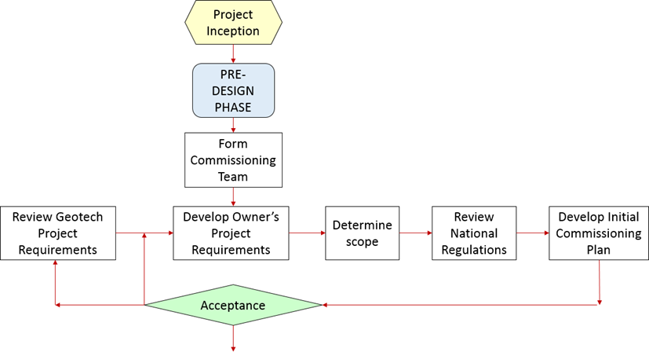
Implementation & commissioning process flow chart

OWNER PROJECT REQUIREMENTS
The OPR lists the main requirements to be fulfilled by this project. Those requirements are provided by the EU project document and by managers of each site. The document must be signed by the owner/responsible of the site.
- Implementation of a TCM system, for saving energy in air conditioning and hot water generation.
- The system must have an acceptable energetic performance.
- The amount of energy provided by the new system must be high enough to assess and validate its usefulness.
- The installation must be carried out in a location where PV systems are existing or can be installed in the future.
- Careful monitoring of the functioning and the results.
- The system must be reliable, and its maintenance must be easy.
- The system must not represent an important increase in risks (fire safety, toxicity...).
- ….
- ….

COMMISSIONING TEAM
A list of agents of the commissioning process.

NATIONAL REGULATIONS
A list of national regulations that must be followed during the project.
The basic regulations applicable to this project are as follows:
LAW 20/2009, of December 4, on prevention and environmental control of activities.
- Law 3/2010, of 18 February, on fire prevention and safety in establishments, activities, infrastructures and buildings.
- DB-SI Safety in case of fire of the Technical Building Code.
- DB-SUA Safety of use and accessibility of the Technical Building Code.
- DB-HE Energy saving of the Technical Building Code.
- DB-HR Protection against the noise of the Technical Building Code.
- DB-HS Health of the Technical Building Code.
- Regulation of fire protection installations, approved by Royal Decree 513/2017, of 22 May.
- Low Voltage electrotechnical regulation, according to RD 84272002.
- Regulation of Thermal Installations of buildings.
- Technical regulations for the distribution and use of gaseous fuels and their complementary technical instructions ICG 01 to 11 approved by Royal Decree 919/2006, of 28 July.
- Regulations for Lifting Devices and their Maintenance.

PRE-DESIGN PHASE TESTS
Check list:
- OPR development
- Commissioning team established
- National regulations listed
- ….

DESIGN PHASE
The following needs to be included in the Design Phase section for TES and PCM facilities & HVAC systems. This will be the basis for Construction Phase documents for contractors, vendors, and equipment/assembly manufacturers:
- List of items required for the Basis of Design.
- Revision review procedure for Commissioning Team members and Owner’s Project Requirements.
- List of coordination requirements and items provided by others. Key milestones that need to be reviewed.
- Update lists of specialists required to implement the Commissioning Process based upon the actual design and interrelationship with other systems and assemblies.
- List of items to be included in the construction documents.
- Develop lists of priority items and relate whenever possible to safety, health, energy, environmental impact, esthetics, operations and maintenance, in addition to Owner’s Project Requirements.
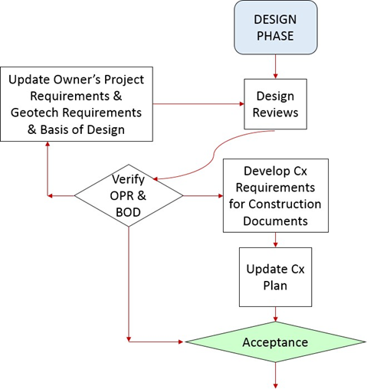
Implementation & commissioning process flow chart

DETAILED P&ID
Functioning schemes.
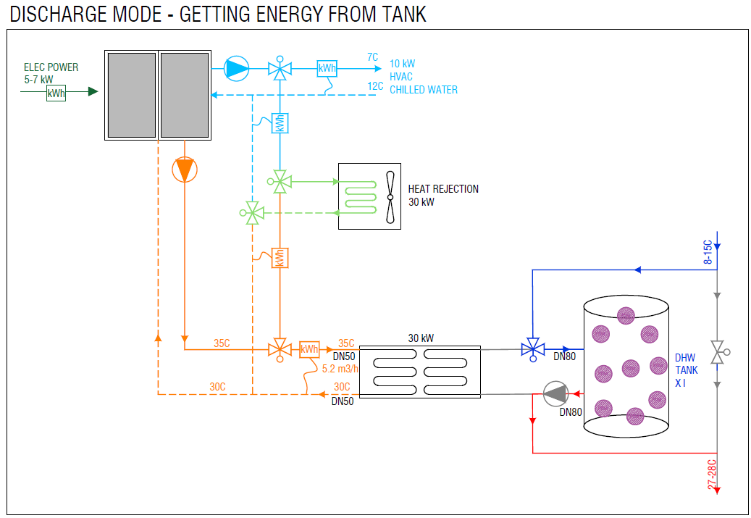
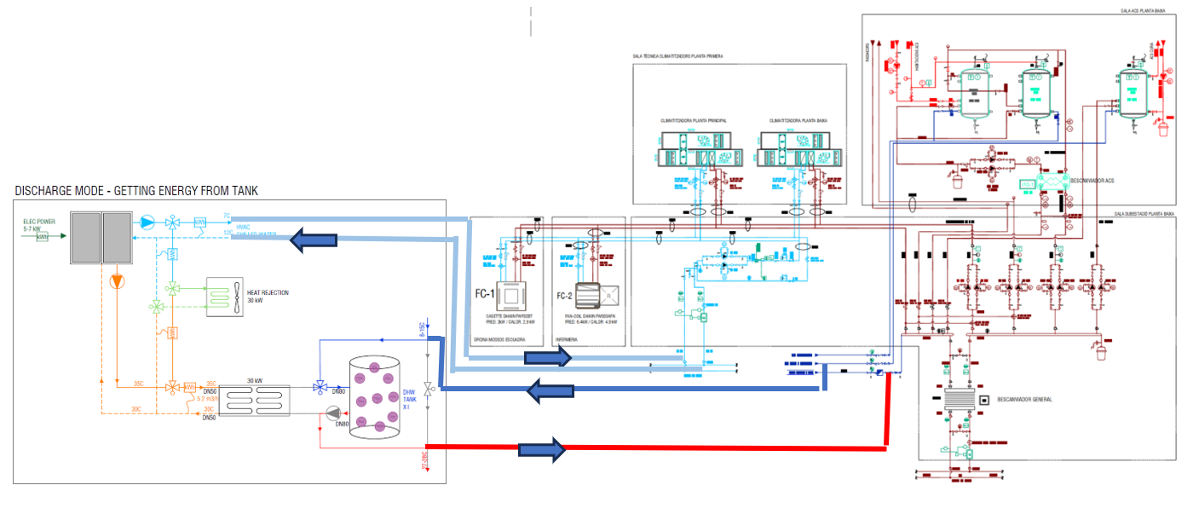

BASIS OF DESIGN
A detailed check list of the parameters to be achieved by the system:
- Maximum heating power provided: 30 kW
- Maximum cooling power provided: 10 kW
- Heat rejection capacity: 30 kW
- Energy storage: 30 kWh…
- Supply/return temperature of water provided: 35C-30C
- Energy performance: …
- Occupied surface: 10 m2.
- Electrical consumption: 3-5 kW…
- Weight:…

DESIGN PHASE TESTS
Detailed verification of every element in the system:

CONSTRUCION PHASE
The following needs to be included in the Construction Phase section for geothermal facilities & HVAC systems:
- List of test procedures and data forms to verify achievement of Owner’s Project
- Requirements and Basis of Design.
- Samples of test procedures and data forms.
- List of coordination requirements and items provided by others. List of specific items for the site visit procedures.
- Tests needs and schedule. Commissioning Team meetings. Issues Logs.
- Input into the final Commissioning Process Report.
- List of items required for acceptance of Construction Phase commissioning.

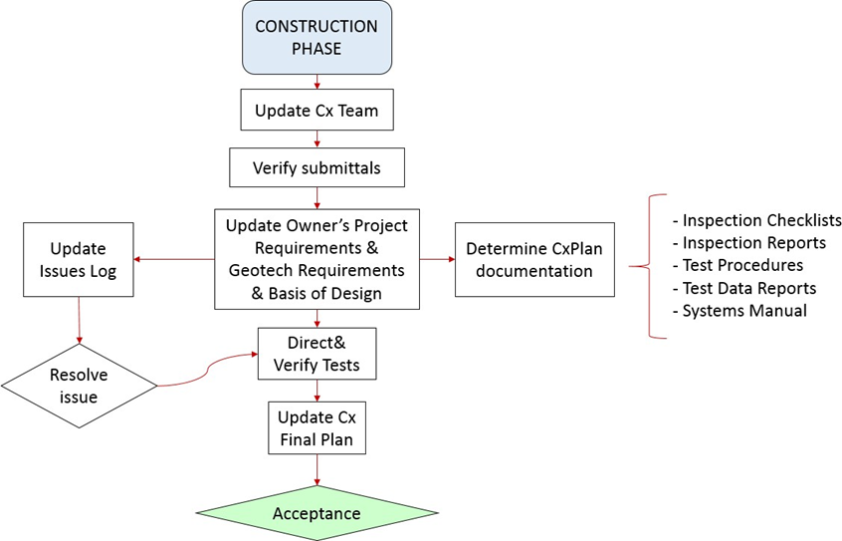
Implementation & commissioning process flow chart

CONSTRUCTION PHASE TESTS
Detailed verification of BOD, OPR and every element in the system:
- Pumps
- Heat pumps
- Valves
- Sensors…
- Wires
- Switches…
- …
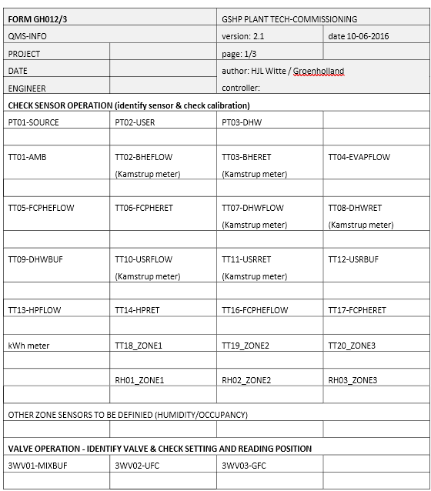
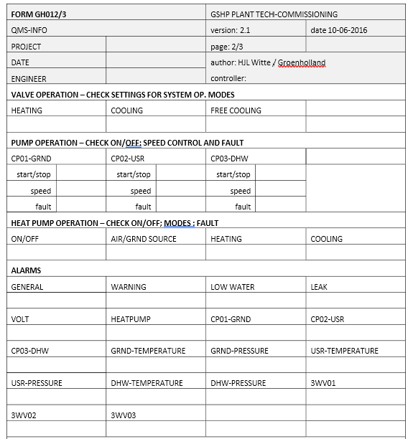

Test 1 : Requisitos previos
Test 2: Disponibilidad de documentación
Test 3: Revisión de P&ID, planos y esquemas
Test 4: Calibración de sondas
Test 5: Caracterización de componentes
- Purging of system
- Leak test – testing of all connections and components
- Strength test – test strength of PE material
- Introduction of anti-freeze
- Circulation medium properties and quality assessment
- Electrical connections
- Hydraulic connections, hydraulic network and directions
- Mechanical aspects (accessibility of plant)
- Electrical contractor to verify quality of supply and earth, phase rotation (if required) and earth-bonding. Electrical certificate to be issued before works can proceed
Test 6: Señalización
Test 7 HSE
Test 8: Operativa funcional
- Verification of all I/O: sensors correctly connected, motorized valves correctly
- connected, pump motors correctly connected, heat pump control correctly connected
- Verify all sensors functioning (sensor readout range and basic calibration) Verify all motorized valves functioning (correctly setting position and feedback
- Verify all pump functioning, pump commissioning
- Verify heat pump operation and communication
- Check water pressure, water quality and de-airing
- Check and commission flow rates

Test 9: Integración en BUCS: Verificación de señales
Test 10: Integración en BUCS: Verificación del software de PLC
Test 11: Integración en BUCS: Verificación del modo de operación
Test 12: Integración en BUCS: Verificación de alarmas
Test 13: Integración en BUCS: Gestión de parámetros
Test 14: Integración en BUCS: Audit trail
Test 15: Integración en BUCS: Verificación de Registros Históricos
Test 16: Integración en BUCS: Regulación de las variables del PID
Test 17: Traslado de los planos y esquemas de la instalación a planos de Novartis
Test 18: Creación de planes de calibración
Test 19: Redacción de SOP’s
Test 20: Creación de planes de mantenimiento

POST-COMMISIONING (MONITORING PLAN)
The purpose of the monitoring is to document the actual seasonal performance of the systems in different usage- and climatic settings as well as evaluation of the performance of the control algorithm and heat pump operation. This means that two monitoring protocols are being implemented.
The standard monitoring of the system will collect data continuously on ambient conditions, operational parameters (temperatures, flow rates), system parameters (set points, operating mode) and energy delivered and consumed at a data logging interval of ± 10 minutes (sensor data) and logging on change-of-value for system parameters.
The monitoring plan for the evaluation of the control algorithm will be implemented at higher frequency (data collection 10 seconds). This data will include controller parameters such as PID controllers output, ANN input and output and other key parameters. This monitoring will be triggered by a supervisor and not collected continuously.
The data-points and key performance indicators that have been selected for the monitoring are listed in the table below. This list may be updated as-needed during the implementation of the controller software and installation of the plug-and-play systems.

Parts of the monitoring system
The data acquisition, either with measurement equipment or equipment integration, will be completely automatic. All the monitoring of the system should be done with the control and supervision equipment.
Data acquisition will be done with the SCADA system and all this data will be saved in its data server.
The data to be collected by the system is not the same data to be used on the energy analysis. The system will first compile the collected data and then do the reports with the processed data.
Appendix shows an example of the control points list to be monitored in a large scale system. The control list is classified according to the subsystem that monitories: environmental conditions, geothermal production, conventional production, domestic hot water and air supply unit, air handling unit and fan-coils.
Control points are classified according to its type of signal:
- Temperature Input (TI)
- Analog Input (AI) Digital Input (DI) Analog Output (AO) Digital Output (DO) Integration (Int)
Signals highlighted in gray are those necessary for the control system and therefore for the
monitoring plan.

Evaluation points
The following main points will be shown in the reports:
- Thermal energy production, measured in both heating and cooling energy meters
- Maximum power in heating and cooling operation mode
- Running time of each compressor and the free-cooling exchanger Seasonal SEER and SCOP
- EER and COP in best conditions
- Heat distribution between HVAC and Domestic Hot Water (DHW)
- Balance between heat or cold injected in the heat exchanger in order to prevent the saturation of the ground

CONCLUSIONS

Summary of achievements
In this document a implementation & commissioning protocol and monitoring plan for the three plug-and-play demo sites has been developed. The commissioning protocol for the Plug and Play sites is based on the standard Groenholland commissioning protocol for large scale systems and describes a detailed commissioning needed for the demo sites. For the actual commercial implementation of these systems a simpler commissioning protocol will be developed as part of the final design documentation.
Both the commissioning protocol and monitoring plan will be adapted to the actual demo site installation. Also, depending on the final controller algorithm implemented, the monitoring plan will be tailored to the specific data-points and key performance indicators.
For the large scale demo sites the implementation and commissioning process has been described also the report shows a generic monitoring plan that combines both the energy production from geothermal technology and from conventional equipment.
The results of this document are the basis for the commissioning of the large-scale tertiary building in Barcelona (tasks 6.5 and 6.6).

Relation to continued development
This deliverable is related to the development of the dual source heat pump and P&P controller (WP4) as well as to the final implementation of the three demo sites.
For the large scale demo site, the results of this task are mainly to be used as input to the tasks 6.5 – 6.6 of WP6.



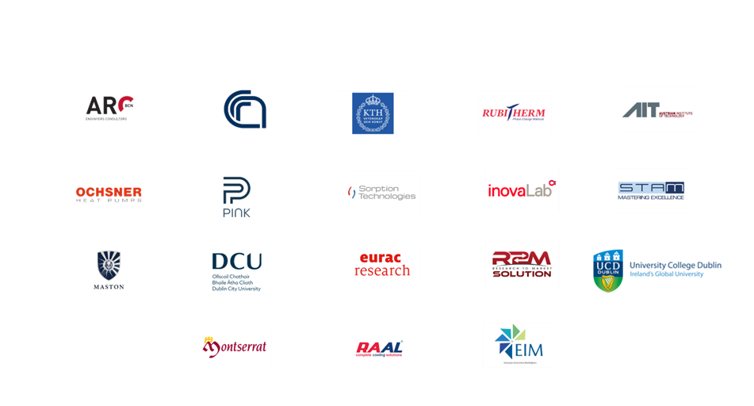

Name SURNAME, ORGANIZATION
Name SURNAME, ORGANIZATION

